TITLE

(TIMES NEW ROMAN, 14 FONT SIZE, BOLD, ALL CAPS, CENTERED)

Author’s Name and Surname¹, Author’sName and Surname² (10font size)
¹Affiliation, E-mail
²Affiliation, E-mail

ABSTRACT (11 Font Size, bold, all caps)

Abstract should be written in 200 words or less and with 10 font size, Times New Roman, justified, single line spacing. The objectives, methods and findings should be summarized in this section.

Keywords:Keywords should contain maximum 5 words that are written with 10 font size and separated with commas.

1. INTRODUCTION (11 Font Size, bold, all caps)

Extended abstracts should be written in a shorter form than the full paper.The text should be formattedin Times New Roman, 11 font size, justified, single line spacing and can contain figures, tables, formulations. Page format should be A4 page size with margins 2.5 cm wide from the right, left, top and bottom. Extended abstracts should not exceed 2 pages including the references and pages should not be numbered.

2. MATERIALS AND METHODS

All materials and methods that have been used in the work must be clearly stated and described in sufficient details or with references.

3. RESULTS AND DISCUSSION

The results of the work should be explicitly described and illustrated. Supporting figures, tables and images of the results(no more than two figuresand/or tables)may be included in the extended abstract.

All of the figure and table should be centered. Figures and images should be numbered together (Figure 1) and figure title should be placed under the figure. The tableshould also be numbered (Table 1) and the table header should be placed at the top of the table. Table, image and figure headers should be written with upper case initial letters, bold and should be centered.

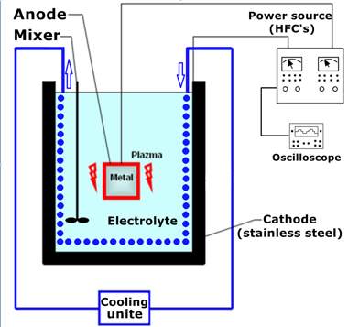

Figure 1. Figure Header

Table 1. Table Header
 | Young’s modulus (GPa) | Poisson ratio | Size
CNT | 1250 | 0.3 | Diameter = 25 nm
PP | 1.98 | 0.42 | Depends on number of fillers
Interphase | 0.99, 3.96 | 0.42 | Thickness = 20 nm

4. CONCLUSIONS
Conclusions should include the most important findings inferred from the results, andthe future works and recommendations (3-4 lines).

REFERENCES
References should be listed in alphabetical order and presented in a format according to APA6th Style.

